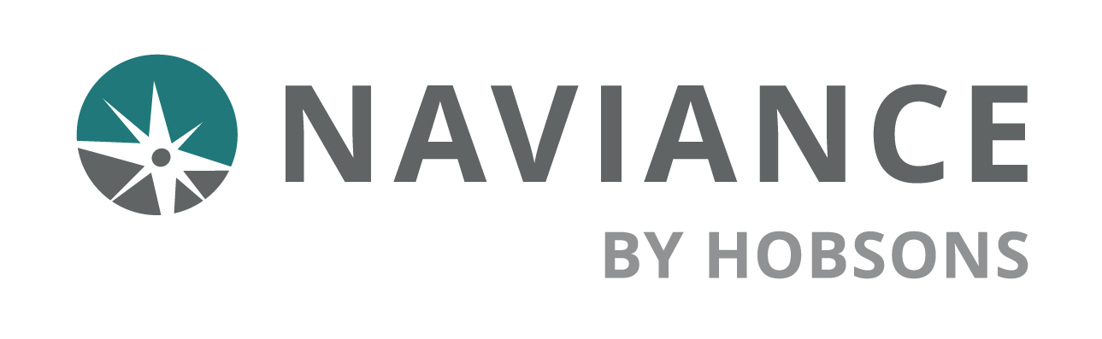Career Planning Tools

Reference Guide

# Overview

Use the Career planning tools in Naviance Student to find best fit careers and clusters and pathways of interest, connect to careers of interest, be inspired by leaders who have turned their passions into life’s work, and locate local, real-world career learning events and opportunities. Find your passion and start planning for your future today!

# Explore Careers

To explore careers in Naviance Student, go to Careers > Explore Careers.

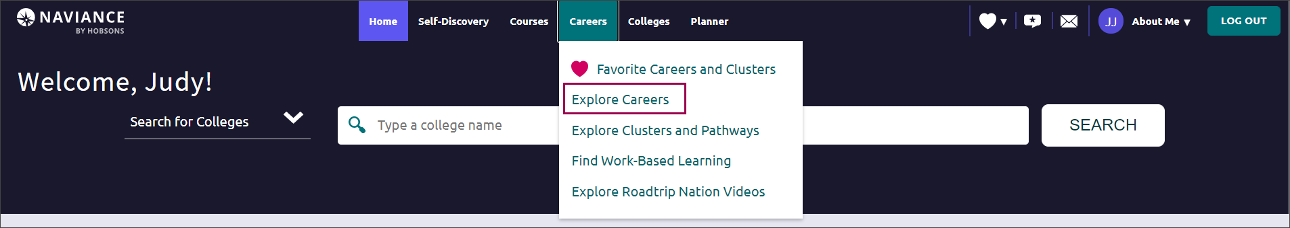

## Career Search

Careers will be listed in alphabetical order by default with several options to find specific careers.

Options include:

**Search**: Type a career name in the search field, then click Go.

**Sort By**: Click the drop-down arrow and select title, education, or salary to sort the list of careers.

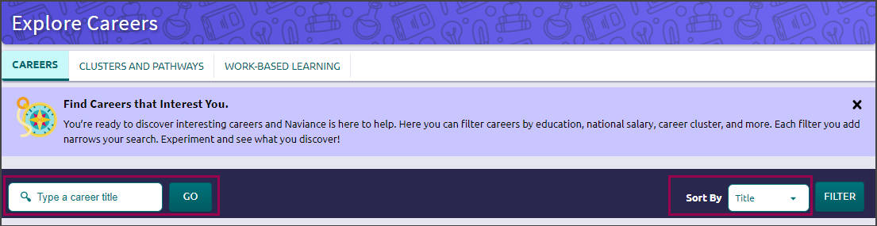

**Filter**: To display the filter menu, click Filter. From the filter menu, choose from Education, Salary, Cluster and Pathway, Holland Traits, Assessment Results, and Favorites. Click Apply to generate a list of careers that are exactly what you are looking for.

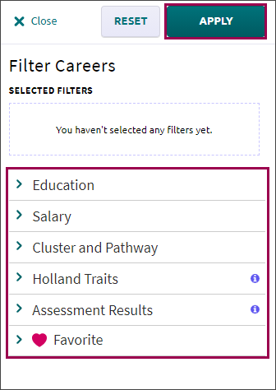

## Career Profiles

To find out more about each career, click on the career name.

Find information such as:

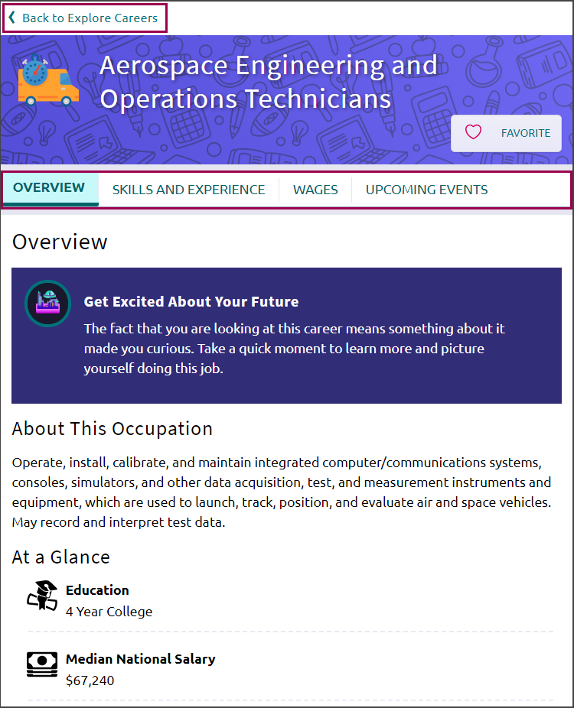**Overview**: Information may include

* education requirements
* related clusters and pathways
* related Holland Traits
* and more

**Skills and Experience**: Get an idea of what someone in this career does at work by learning about:

* Important knowledge areas
* Skills needed
* Key abilities
* Activities carried out during the workday
* Tasks performed

**Wages**: Find the average rate, salary or hourly, by country, state, or city.

**Upcoming Events**: See any Work-Based Learning events or opportunities shared by your school that are related to the career.

 To close the career profile and return to the list of careers, click Back to Explore Careers.

## Favorite Careers

Add careers of interest to a list of favorites by clicking on Favorite. *In Favorites will display along with a red heart.*

To remove a career from your list of favorites, click on In Favorites. *Favorite will display with an empty heart.*

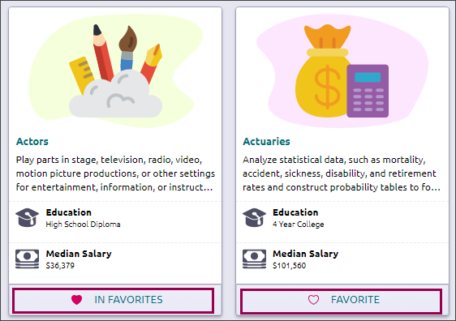

# Explore Clusters and Pathways

To explore careers in Naviance Student, go to Careers > Explore Clusters and Pathways.

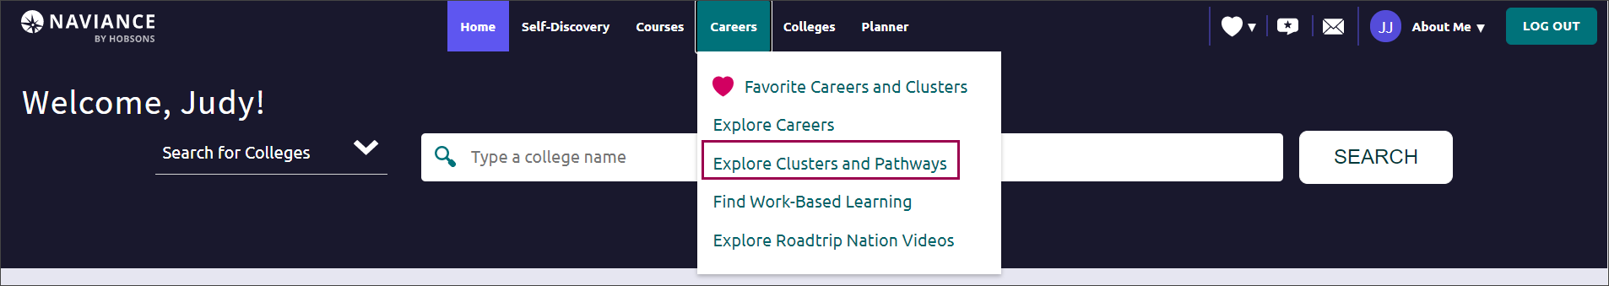

Career Clusters will be listed in alphabetical order. Click on the arrow to display cluster information and related pathways.

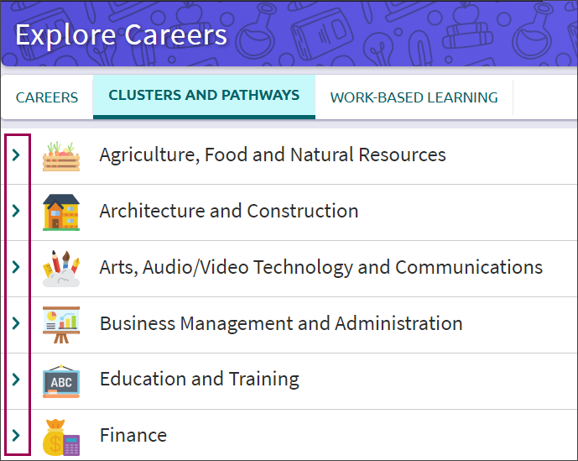

## Cluster Profiles

To learn more about the cluster, click Read Details.

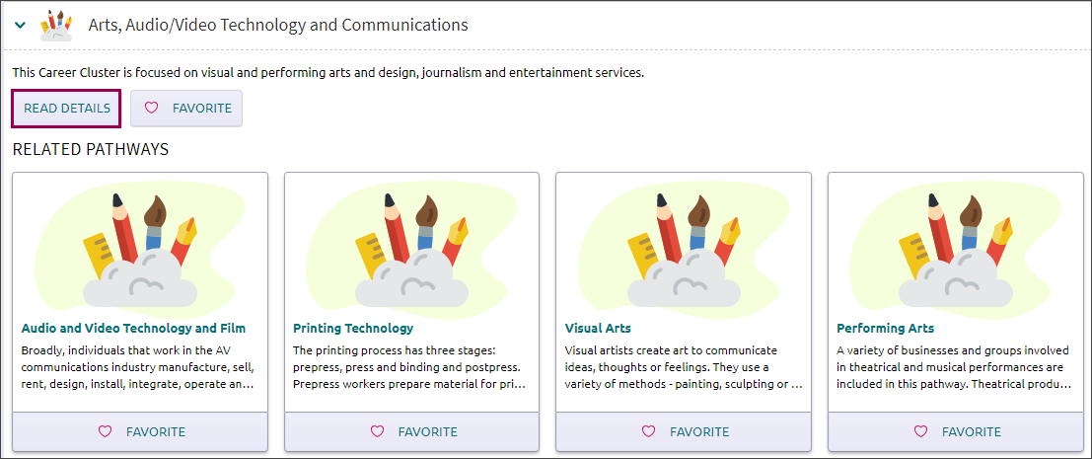

An overview of the cluster, related pathways, and additional information will display.

Additional information may include:

**Upcoming Events:** See any Work-Based Learning events or opportunities shared by your school that are related to the cluster.

**Employment Outlook**: Find information such as the number of jobs, employment rates, and more.

**Related Occupations**: View a list of careers related to the cluster.

**Related Majors**: See a list of college majors to pursue that are related to the cluster.

**Plans of Study:** See a list of recommended courses by grade and subject area. *(Source: Advance CTE)*

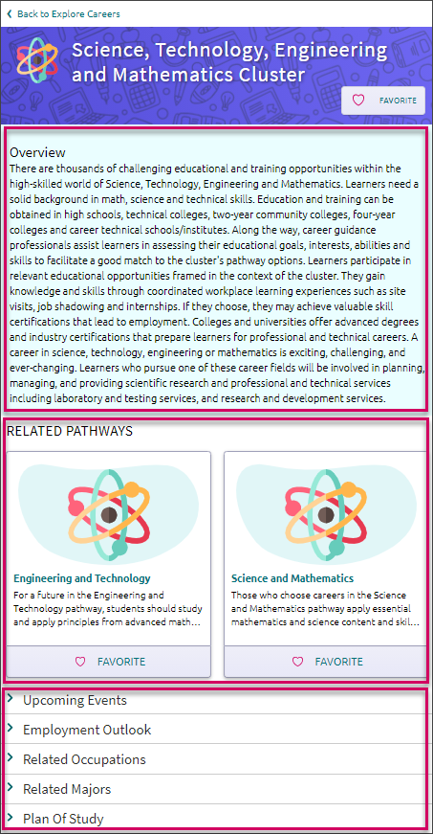

To close the cluster profile and return to the list of clusters, click Back to Explore Careers.

## Pathway Profiles

To access information about the Pathway, click the Pathway title.

Additional information may include:

**Upcoming Events**: See any local events or opportunities shared by your school that are related to the cluster.

**Employment Outlook**: Find information such as the number of jobs, employment rates, and more.

**Typical Credentials**: Learn about the required degree, certificate, or licensure.

**Related Occupations**: View a list of careers related to the cluster.

**Related Majors**: See a list of college majors to pursue that are related to the cluster.

**Plans of Study:** See a list of recommended courses by grade and subject area. *(Source: Advance CTE)*

To close the pathway profile and return to the list of clusters, click Back to Explore Careers.

## Favorite Clusters and Pathways

Add clusters and pathways of interest to a list of favorites by clicking on Favorite. In Favorites will display along with a red heart.

To remove clusters and pathways from your list of favorites, click on In Favorites. Favorite will display with an empty heart.

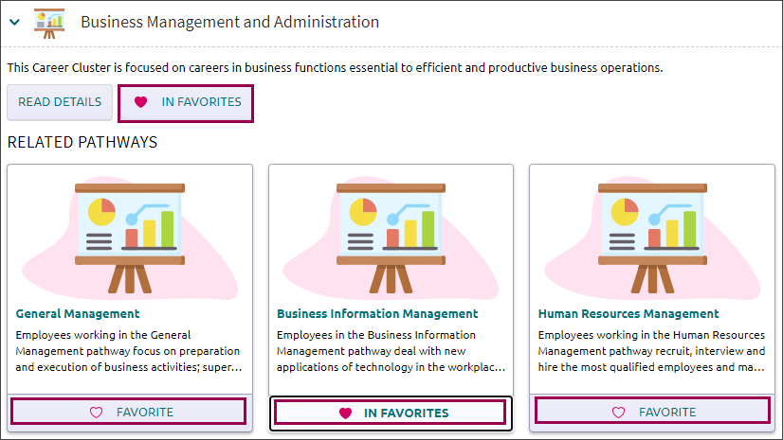

# Favorite Careers and Clusters

You can your list of favorite careers, clusters, and pathways in one of three ways:

* Go to Careers > Favorite Careers and Clusters.
* Favorites (heart icon) > Favorite Careers and Clusters.
* Naviance Student Home > My favorites > Careers and Clusters I'm Thinking about.

In **My Favorite Careers and Clusters,** favorited careers, clusters, and pathways will be listed in alphabetical order. To see only careers, clusters, or pathways in your favorites list, click the Show Types drop-down arrow and choose an option.

 To remove careers, clusters, or pathways from your list of favorites, click on Favorite.

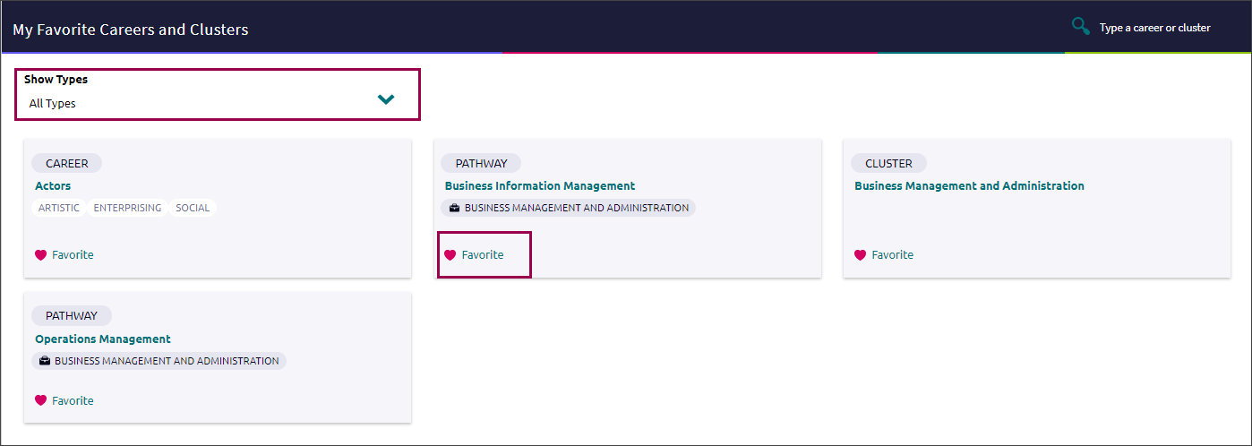

In **Suggested Clusters and Pathways**, you'll see a list of clusters and pathways generated by Naviance based on your list of favorites.

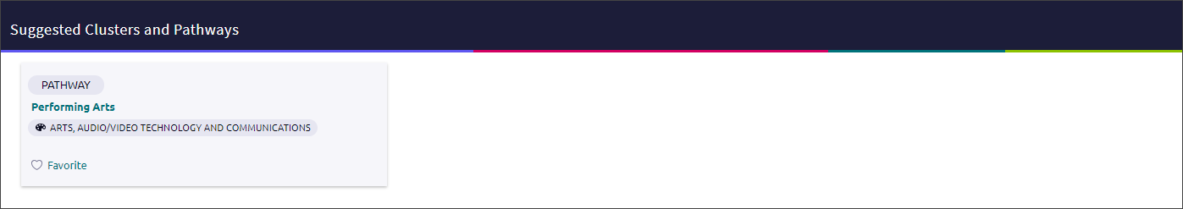

# Find Work-Based Learning Events

Find meaningful, real-life experiences in Naviance Student to help support your college and career interests and goals after high school. The Work Based Learning experience includes opportunities shared by your school, which may include:

|  |  |
| --- | --- |
| * Guest Speakers | * Internships |
| * Field Trips | * Externships |
| * Career Fairs | * Job Shadows |

To access this new feature in Naviance Student, go to Careers > Find Work-Based Learning.

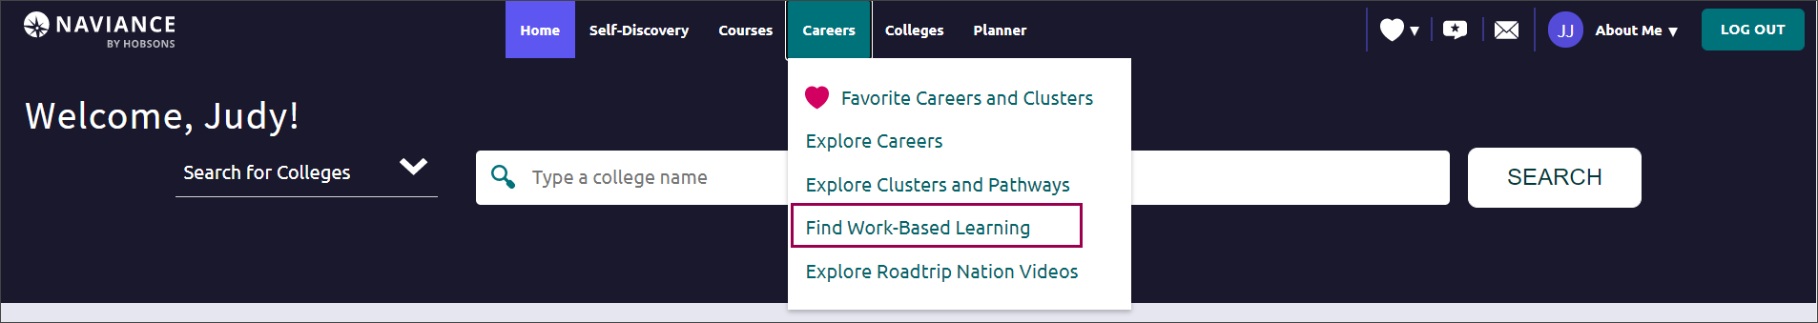

### Work-Based Learning events/opportunities can also be found in the Upcoming Events sections of related career, cluster, or pathway profiles, if available.

## Search Work-Based Learning Events

Work-Based Learning events will be listed in event date order with several options to find specific events:

**Event Type**: Select the event type dropdown and choose to display only guest speakers, field trips, career fairs, internships, externships, or job shadows.

**Sort By:** Click the drop-down arrow and change the display to see events starting with the furthest date or closest date.

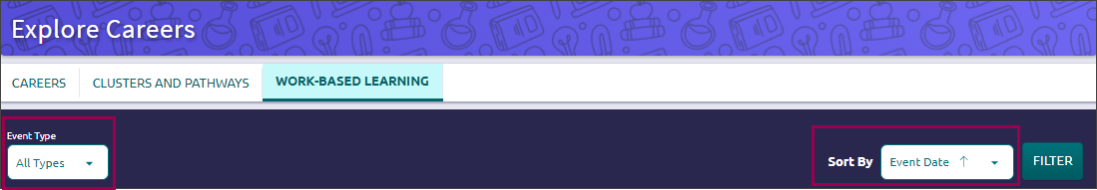

**Filter**: Click Filter to display the filter menu. Choose from Event Type, Cluster, Events RSVP, Event Date, or Favorite. After making selections, click Apply to generate a list of work-based events and opportunities that are exactly what you are looking for.

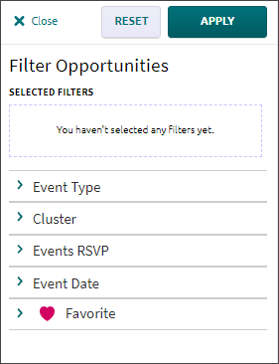

## Event Cards

Each event card contains basic information such as:

|  |  |
| --- | --- |
| * + Event Date | * + Event Title |
| * + Event Type | * + Date |
| * + Location | * + And more |

### Online events will be highlighted in yellow.

Click Apply or Attend to indicate if you will participate in the event.

Choose Favorite to add the event to your list of Work-Based Learning Favorites. **In Favorites** will display along with a red heart.

To remove an event from your list of favorites, click on **In Favorites**. **Favorite** will display with an empty heart.

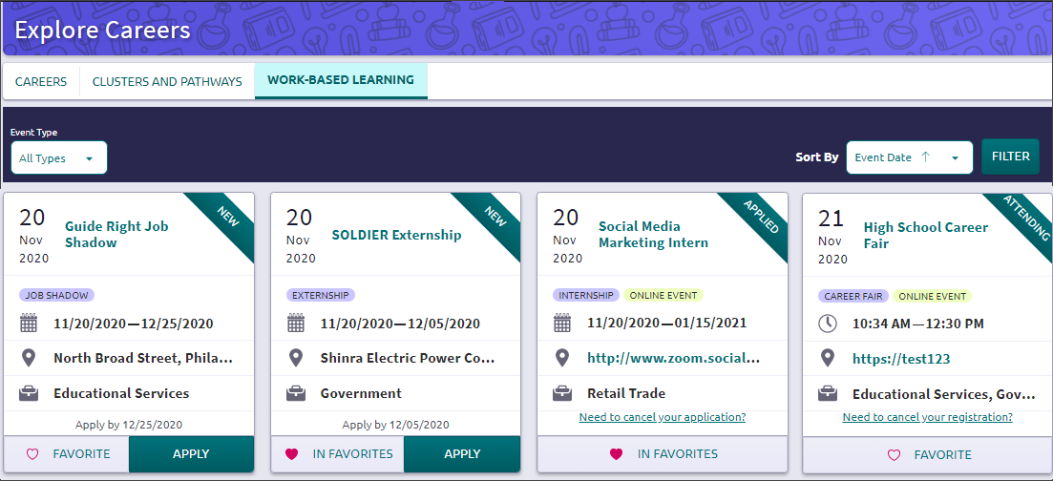

### To access your list of Work-Based Learning Favorites, click **Filter > Favorite** and click **Opportunities in Your Favorites**. A checkmark will display. Click **Apply** and a list of your Work-Based Learning favorites will display.

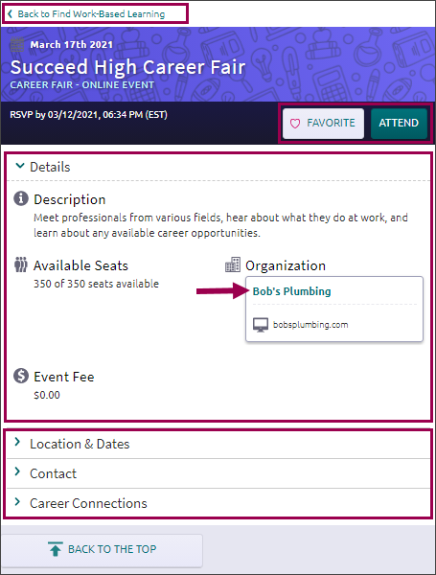

## Event Details

To see all information about the event, click on the event title to access the details page.

Details such as a Description, Available Slots, Organization, and Salary & Benefits will display along with:

* Location and Dates
* Contact
* Career Connections

Options to add the event to your Favorites and to indicate that you are interested in attending or applying are also available.

Click Back to Work-Based Learning at the top of the details page to return to the Work-Based Learning dashboard.

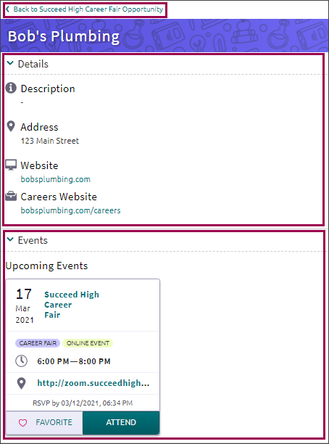

## Organization Details

To view the related organization details, click on the Organization name.

In the Details section, information such as organization address and website will display.

In the Events section, cards will display for any upcoming events related to the organization.

To return to the opportunity details page, students will click Back to Opportunity at the top of the organization details page.

# Explore Roadtrip Nation Videos

The Roadtrip Nation Interview Archive is a digital career exploration tool that enables students to access more than 8,000 video interviews chronicling the diverse personal stories of leaders who have turned their interests into their life’s work.

To access Roadtrip Nation in Naviance Student, go to Careers > Roadtrip Nation Interview Archive.

There are five search options available in the video archive:

**What's Your Road?** – Find your road with the What's Your Road? Feature. Choose a foundation and two interests, then the What's Your Road? feature will match you to leaders with similar roads.

**by Playlist** – Choose a pre-assembled playlist consisting of video interviews from leaders.

**by interests** – Choose from the listed interest categories (e.g. medicine, art, business) and explore interviews in fields that align with your interests.

**by Themes** – Choose from the listed themes (e.g. risk, failure, determination) in which leaders specifically address their own trials and learning related to the particular theme.

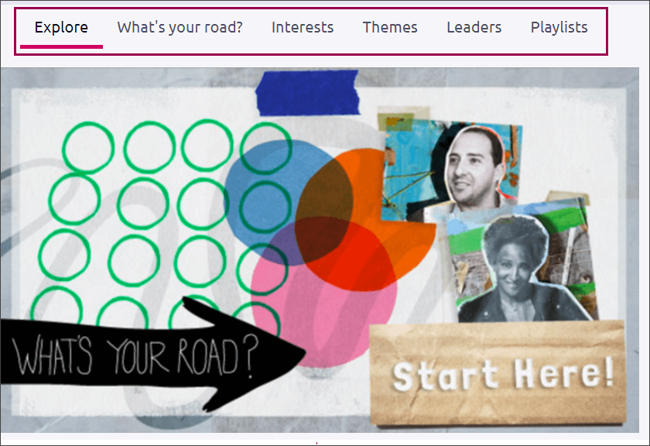**by Leaders** – Choose from all the leaders interviewed. You can filter the list as needed.