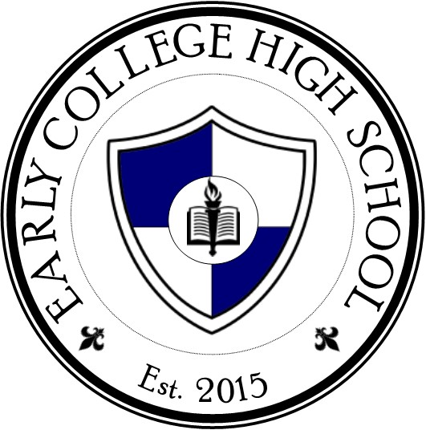Description: j0332680

JCM Early College High School

“A Title I School-wide Program”

Dr. Nathan Lewis – Principal

Shannon Davis – Assistant Principal

David Westberry – Assistant Principal

Latonia Vann – School Counselor

731-664-2575

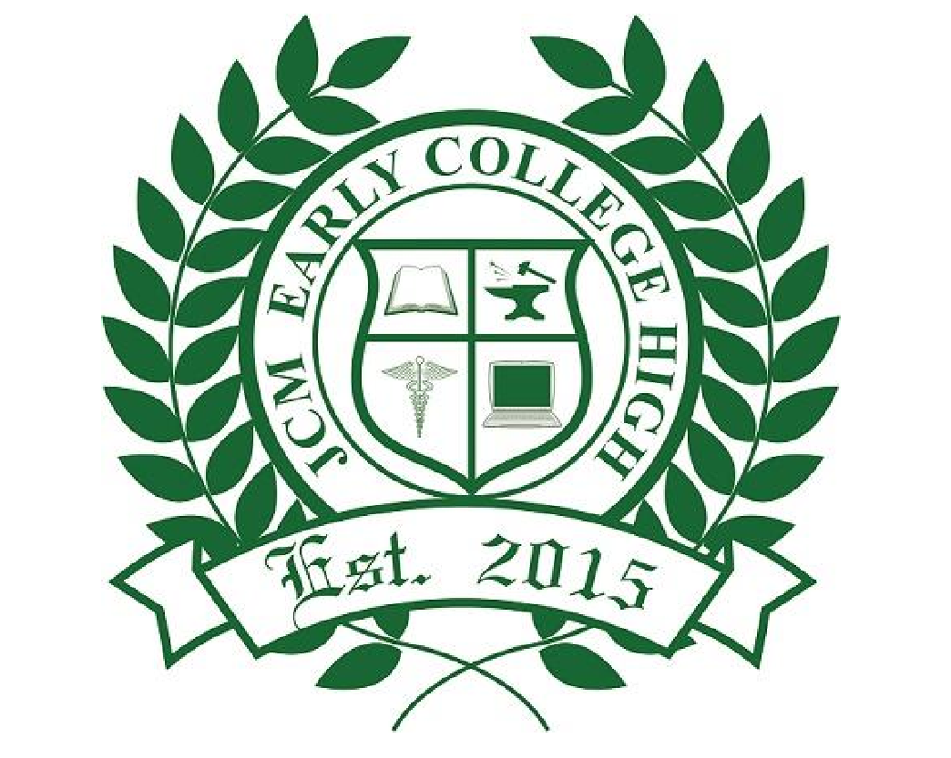

**Jointly Developed**

The parents, students, and staff of JCM Early College High School developed this School-Parent Compact for Achievement. Teachers suggested home learning strategies, parents added ideas to make them more specific, and students told us what would help them learn. Meetings are held each year to review the Compact and make changes based on student needs.

* Parents are welcome to contribute comments at any time.
* If you would like to *volunteer, participate*, and/or *observe* in the classroom, please contact: Nathan Lewis, Shannon Davis, or David Westberry.

# **What is a Family-School Compact?**

A *School-Parent Compact for Achievement* is an agreement that parents, students, and teachers develop together. It explains how parents and teachers will work together to make sure all students reach grade-level standards.

Effective compacts:

* Focus on student learning skills.
* Link to goals of the school improvement plan.
* Describe how teachers will help students develop those skills using high-quality instruction.
* Share strategies parents can use at home.
* Explain how teachers and parents will communicate about student progress.
* Describe opportunities for parents to volunteer. observe, and participate in the classroom

**SCHOOL-PARENT**

**COMPACT FOR ACHIEVEMENT**

**2022-2023**

**Activities to Build Partnerships**

Opportunities to volunteer and participate in your child’s school:

* Provide back to school nights and Parent Teacher Conferences at strategic times throughout the year.
* Welcome parents to visit the school for student activities.
* Administrative open door policy to address any issues or concerns with parents.
* Partner with parents for special nights such as plays, concerts, and sports events.

**Parents-Right-to-Know**

A parent has the right to request certain information about their child’s teacher including:

* Whether the teacher has met State qualification and licensing criteria for the grade levels and subject areas in which the teacher provides instruction;
* Whether the teacher is teaching under emergency or other provisional status through which state qualification or licensing criteria have been waived;
* The baccalaureate degree major of the teacher and any other graduate certification or degree held by the teacher, and the field of discipline of the certification or degree; and
* Whether the child is provided services by paraprofessionals and, if so, their qualifications.

## **District Goals**

JMCSS Vision and Mission:

**Vision**: All graduates will be effective problem solvers and have acquired the knowledge and skills to be life-long learners and productive citizens.

**Mission**: To prepare tomorrow’s leaders by providing a safe, caring learning environment, working in cooperation with families and the community and providing appropriate curriculum and effective instruction.

## **School Goals**

School administrators and teachers have studied our

student performance data to decide on the most

important areas of improvement for our school.

* Improving literacy scores as measured by the TNReady assessment by 5 percentage points in growth.
* Improving math scores as measured by the TNReady assessment by 10 percentage points in growth.
* Improving science and social studies scores through an emphasis on balanced literacy and subject specific vocabulary.
* Improve ACT composite average to 22.
* Utilizing data to move students forward.
* Preparing students for success in college courses using college preparation methods and materials. Increase JSCC enrollment by 10 percent, LOOP enrollment by 10 percent, and industry certifications by 15 percent.

**Our Goals for**

**Student Achievement**

**Students**

Students at JCM Early College High School will share the responsibility to improve academic achievement and meet the state’s high academic standards. Specifically, the students will:

* Attend school regularly prepared to work with completed homework assignments.
* Discuss with parent/guardian what is being learned in school.
* Show a positive attitude about learning by respecting parents, teachers, and others.

**At Home**

School parents and staff have developed ideas about how families can support students’ literacy and mathematical understanding. Families may have other suggestions to add to the list.

* Participate in Parent-Teacher conferences twice a year or communicate with classroom teachers if unable to attend.
* Review the Student Handbook/Agenda for important school and district information and policies.
* Review homework and grades using the district’s PowerSchool website. [www.jmcss.org](http://www.jmcss.org)
* Parents are encouraged to discuss what the student is learning in the classroom with the student upon arriving home.
* Encourage reading and studying at home.
* Attend at least one Parent Workshop sponsored by the school and/or district.

**In The Classroom**

JCM Early College High School will work with students and their families to develop students’ literacy and mathematical understanding. Some of our key connections with families will include the following:

* School website provides important individual classroom information with current student assignments.
* Assessment of students on a regular basis and adjustment of instruction to meet student needs.
* Communication with students and parents on a regular basis.
* Utilize PowerSchool to keep parents informed of the student’s grades.

**Teachers, Parents, Students – Together for Success**