




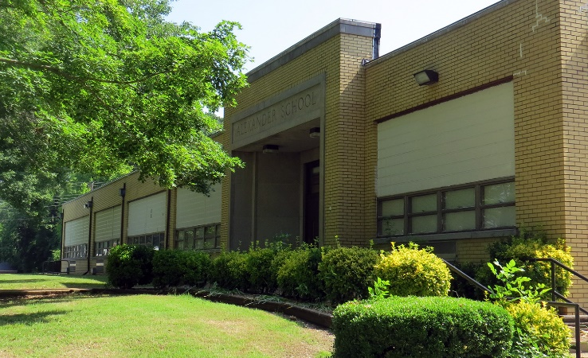
Plan Revised July 31, 2024
2024 - 2025
Parent and Family Engagement Policy for Shared Student Success
Alexander Elementary School
School Plan for Shared Student Achievement

What is it?
This is a plan that describes how Alexander Elementary will provide opportunities to improve family engagement to support student learning. Alexander Elementary values the contributions and involvement of families to establish an equal partnership for the common goal of improving student achievement. This plan describes the different ways that Alexander Elementary will support family engagement and how families can help plan and participate in activities and events to promote student learning at school and at home.

How is it revised?
Alexander Elementary School invited all families to attend our annual School open house last spring to review and revise this parent and family engagement policy, the school improvement plan, our school- parent compact, and the family engagement budget. Additionally, family input and comments regarding this plan are welcome during the school year through an online form. The plan is posted on our school website for families to view and submit feedback throughout the year. All feedback received during the year will be used to revise the plan for the next school year. We also distribute an annual survey online and by mail to ask families for their suggestions on the plan and the use of funds for family engagement. Families can also give feedback during several meetings and activities during the school year.

Who is it for?
All students participating in the Title I, Part A program, and their families are encouraged and invited to fully participate in the opportunities described in this plan. Alexander Elementary will provide full opportunity for the participation of parents and family members with limited English, with disabilities, and of migratory children.

Where is it available?
At the beginning of the year, the plan is included in the student handbook and sent home with all students. As a reminder, we will email the plan to all families in August before the scheduled Open House event. The plan will also be posted on the school website and social media. Families can also retrieve a copy of the plan in the front office of the school.

What is Title I?
Alexander Elementary is identified as a Title I school as part of the Every Student Succeeds Act (ESSA). Title I is designed to support state and local school reform efforts tied to the challenging state academic standards to improve teaching and learning for students. Title I programs must be based on effective means of improving student achievement and include strategies to support family engagement. All Title I schools must jointly develop with parents and family members a written parent and family engagement policy.

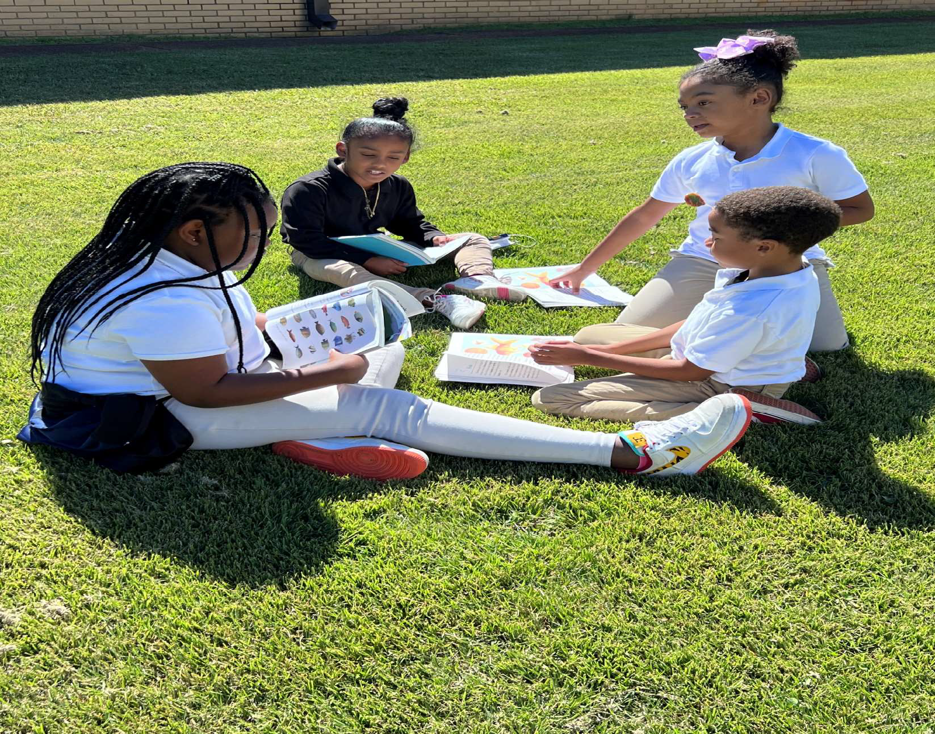
When students, schools, families, and communities come together we CAN achieve our goals!

Alexander Elementary School
Kenton Evans, Principal
900 N. Highland Ave
(731) 422-1841
knevans@jmcss.org


2024-25-District Goals
All schools in the district achievement and growth scores will improve in all content areas grades PreK-12.


2024-2025 Alexander Elementary School Goals
In 2024-2025, increase proficiency on TNReady by 8 percent in reading and math.
The school focus for reading is:
K 1: Beginning sounds and sight words K 4: Vocabulary development
The school focus for math is:
K-6: Place value and estimation

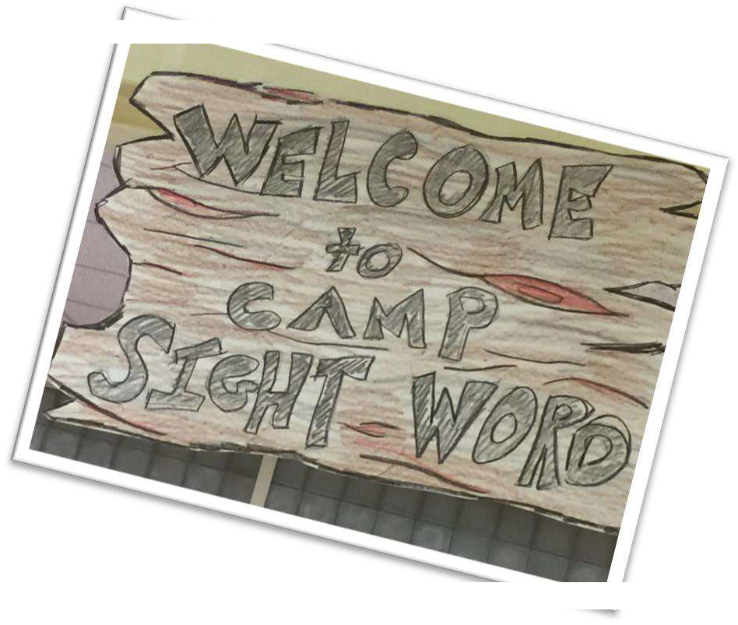
Parent and Family Engagement
Family Engagement means the participation of parents and family member in regular, two-way, and meaningful communication involving student academic learning and other school activities, including ensuring:
learning;

families are encouraged t
-making and on advisory
committees to assist in the education of their child.
The carrying out of other activities, such as those described in Section 1116 of the ESSA.





School-Parent Compacts

As part of this plan, Alexander Elementary and our families will develop a school-parent compact. A compact is a written agreement that families, teachers, and students jointly develop to explain how everyone will work together to ensure all students reach grade-level standards. The compacts will be reviewed and updated annually based on feedback from families, students, and teachers during various events and the annual School Forum. The school-parent compacts are also displayed in each classroom, shared with families during parent-teacher conferences, posted on our school website (www.jmcss.org), and extra copies are always available in the front office. If you would like to provide feedback on the compact any time during the year, please contact knevans@jmcss.org

Alexander Elementary is
branching out!
Alexander Elementary will take the following measures to empower and support families as an important foundation of our school to strengthen the school and reach our goals.
We will:
Ensure that all information related to school and family programs, meetings, and other activities is published in English, Spanish, and Arabic; posted on the school website; and included in the monthly school newsletter for all families.
Provide monthly training for staff during their planning periods on strategies to improve communication with families and ideas to increase family engagement in reading and math for our students outside of the classroom. Staff will also share promising practices in family engagement during regularly scheduled faculty meetings.
Partner with early childhood programs, middle and high schools, college-and career-ready resources or organizations, parent resource centers, or other
programs (as applicable) to help prepare parents and their children for successful school transitioning.

Share information in English, Spanish, and Arabic on the school blog and in the school newsletter for families to understand the academic standards and
and
work with educators.

Alexander Elementary is committed to helping our parents and family members attend the events listed in this policy. Please call or email us if you need assistance with any of our programs.
Kenton Evans (731) 422.1841
knevans@jmcss.org
Communicate with all families and the community on a regular basis regarding schoolwide events and activities, through phone messages, our website, social media, and flyers.

Work with our families to develop relevant trainings and helpful presentations to educate our staff on the importance of parent and family engagement and
how to support student learning.
Provide necessary materials and handouts for parents at conferences, meetings, and activities to help parents work with their child to improve their achievement.


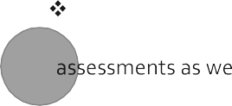




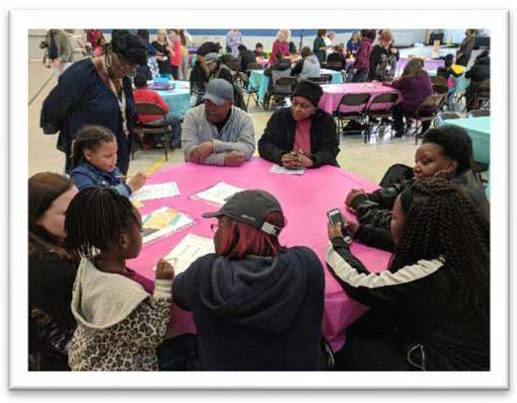

Use our Partners in Education and School Community Team to improve awareness of the activities and events listed in the school parent and family engagement policy.
Offer literacy and computer classes for parents and family members to help further enhance their various educational levels.

Collect feedback from parents and family members at all events, place input cards around the building and post a suggestion form on the school website in
family
engagement activities.


 together!
Alexander Elementary will host the following events to build the capacity for strong family engagement and support a partnership among the school, families, and the community to improve student academic achievement. See the entire listing of events on our website: www.jmcss.org.

Annual Title I Meeting August 1, 2024 and September 19th, 2024
We invite you to an evening of learning and sharing about our Title I program, including our parent and family engagement policy, the schoolwide plan, and the school-parent compact. Invitations will be emailed and posted in the school newsletter and on social media.

Open House August 1, 2024
Meet your child’s teacher and learn about important grade level skills and standards that your child will be working on this year.

Homework Diner To be announced
Learn helpful information about your child’s activities and curriculum used during the school year and spend an evening your child with his/her homework.

Thanksgiving Luncheon To be announced
Families can enjoy a wonderful lunch with the kids during this blessed holiday.
Christmas Program To be announced
To be announced Awards Day To be announced
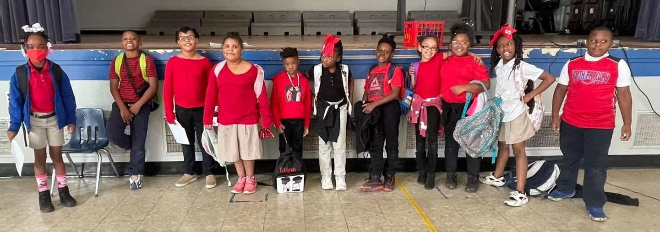
Literacy Night/Book Fair To be announced 5th Grade Graduation - To be announced Kindergarten Graduation - To be announced

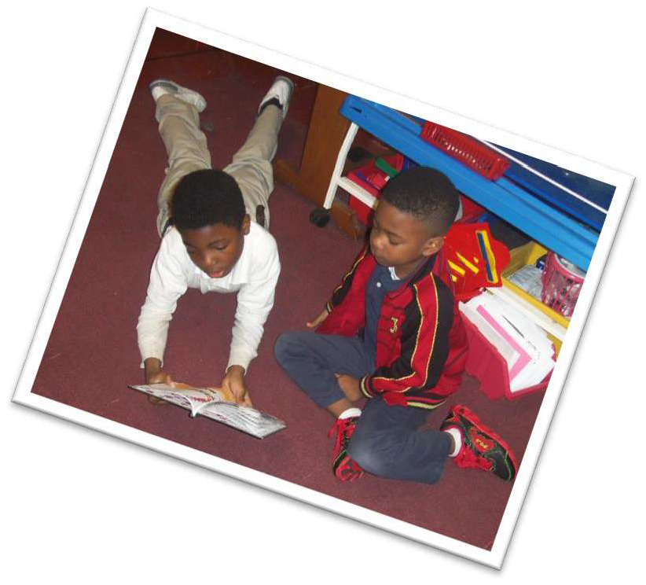
Parent and Family Engagement Standards
Alexander Elementary and our families have adopted the National PTA Standards for Family-School Partnerships as the school’s model in engaging parents, students, and the community. These standards are:

Welcoming All Families
Communicating Effectively Supporting Student Success Speaking Up for Every Child Sharing Power
Collaborating with Community




School Community Team
Yes, I am interested and wish to join the School Community Team.
Please contact me so I can learn more about joining the School Community Team. Please send me notifications about future meetings and updates.
Name:
Grade Level: Address: Phone Number: Email Address:
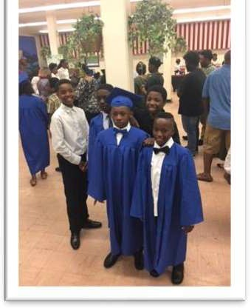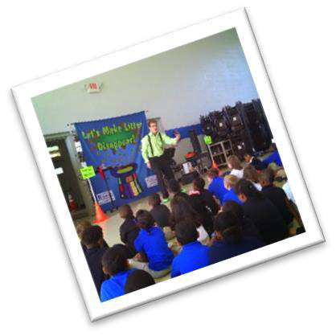
School Community Team
Alexander Elementary invites all families to join the School Community Team to share ideas and ways to involve others to build partnerships with school, families, and the community. The team will meet four times during the school year, but parents and family members can also submit their ideas or suggestions at any school activities and meetings, as well as through our family surveys and website. If you would like to learn more about the School Community Team, please contact Kenton Evans 731.422.1841 or complete the interest form below and leave it in the front office.


Share Your Thoughts


We want to hear from you! If you have any suggestions or if there is any part of this policy that you feel is not satisfactory with
space provided and
leave this form in the front office:
Name (optional): Phone Number (optional):

Comments:

